CHAPTER-1

Computer Networking

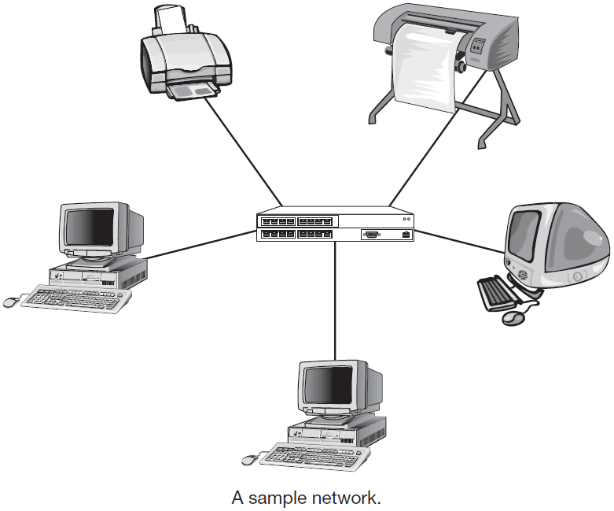
  - Introduction
Computer networking is the organized group of devices (or node) having communication link among them to exchange information or shared resources. A node can be a computer, printer, or any other device capable of sending or receiving data generated by other nodes on the network.

In the old concept of networking, people can access to any computer from any computer and there is no any level of security or permission. But now a days the concept of networking is not only to access to the computer but to access defined user from defined area, and the defined people is also given the certain right which should be the user criteria. This mean the security level is high. And this kind of environment is only possible in client-server configuration but not for the peer to peer configuration.

Computer networks have revolutionized out use of computers. They are used in our everyday life, from automated teller machines, to airline reservation systems, to electronic mail services, to electronic bulletin boards. Some typical network applications are:
- Connectivity to multiple people through electronic mail, social networks
- Sharing of hardware and software resources
- Execute a program on another computer
- Remote login, remote database access
- Information reliability by maintaining multiple backups
- Cost reduction due to multiple resource sharing facility

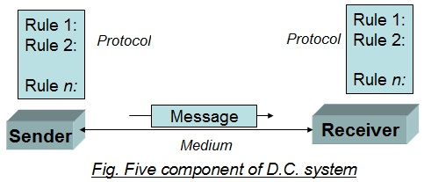
  - Component of data communication
A data communications system has five components:
- Message: The message is the information (data) to be communicated. Popular forms of information include text, numbers, pictures, audio, and video.
- Sender: The sender is the device that sends the data message. It can be a computer, workstation, telephone handset, video camera, and so on.
- Receiver: The receiver is the device that receives the message. It can be a computer, workstation, telephone handset, television, and so on.
- Transmission medium: The transmission medium is the physical path by which a message travels from sender to receiver. Some examples of transmission media include twisted-pair wire, coaxial cable, fiber-optic cable, and radio waves.
- Protocol: A protocol is a set of rules that govern data communications. It represents an agreement between the communicating devices. Without a protocol, two devices may be connected but not communicating, just as a person speaking French cannot be understood by a person who speaks only Japanese. The protocol defines the required quality-of-services (QoS), flow control and error control mechanism, type of services, security paradigms, system consistency etc. The services (e.g. voice transfer) are always constant but the protocols are changes (GSM, CDMA, and PSTN).

  - Characteristics of data communication
Data communications are the exchange of data between two devices via some form of transmission medium such as a coaxial cable, optical fiber or sometime the free air. For data communications to occur, the communicating devices must be part of a communication system made up of a combination of hardware (physical equipment) and software (programs). The effectiveness of a data communications system depends on four fundamental characteristics:
- Delivery: The system must deliver data to the correct destination.
- Accuracy: The system must deliver the data accurately. Data that have been altered in transmission and left uncorrected are unusable.
- Timeliness: The system must deliver data in a timely manner.
- Jitter: Jitter refers to the variation in the packet arrival time.

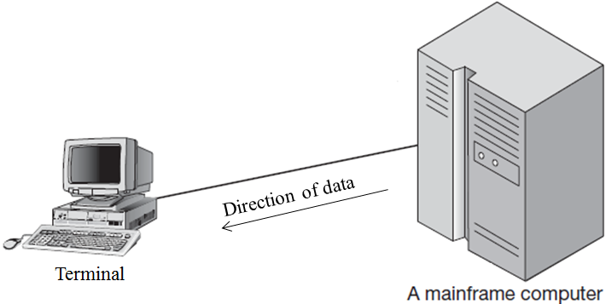
  - Data Flow
Communication between two devices can be simplex, half-duplex, or full-duplex as:
- Simplex
In simplex mode, the communication is unidirectional, as on a one-way street. Only one on a link can transmit; the other can only receive like TV broadcast, radio broadcast. Also, Keyboards and traditional monitors are examples of simplex devices. The keyboard can only introduce input; the monitor can only accept output. The simplex mode can use the entire capacity of the channel to send data in one direction.

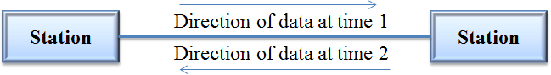
- Half-Duplex:
In half-duplex mode, each station can both transmit and receive, but not at the same time. When one device is sending, the other can only receive, and vice versa. The half-duplex mode is used in cases where there is no need for communication in both directions at the same time; the entire capacity of the channel can be utilized for each direction.

The half-duplex mode is like a one-lane road with traffic allowed in both directions. When cars are traveling in one direction, cars going the other way must wait. In a half-duplex transmission, the entire capacity of a channel is taken over by whichever of the two devices is transmitting at the time. Walkie-talkies and CB (citizens band) radios are both half-duplex systems.
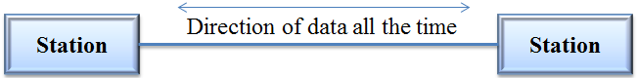
- Full-Duplex:
In full-duplex mode (also called duplex), both stations can transmit and receive simultaneously. The full-duplex mode is used when communication in both directions is required all the time. The capacity of the channel, however, must be divided between the two directions. One common example of full-duplex communication is the telephone network. When two people are communicating by a telephone line, both can talk and listen at the same time.

The full-duplex mode is like a two-way street with traffic flowing in both directions at the same time. In full-duplex mode, signals going in one direction share the capacity of the link: with signals going in the other direction. This sharing can occur in two ways: Either the link must contain two physically separate transmission paths, one for sending and the other for receiving; or the capacity of the channel is divided (can be frequency division duplexing, FDD or time division duplexing, TDD) between signals traveling in both directions.
  - Modulation
Modulation can be defined as superimposition of the signal containing the information on a high-frequency carrier. If we have to transmit voice that contains frequency components up to 4 kHz, we superimpose the voice signal on a carrier of, say, 140 MHz. The input voice signal is called the modulating signal. The transformation of superimposition is called the modulation. The hardware that carries out this transformation is called the modulator. The output of the modulator is called the modulated signal (baseband signal + carrier signal). The modulated carrier is sent through the transmission medium, carrying out any other operations required on the modulated signal such as filtering. At the receiving end, the modulated signal is passed through a demodulator, which does the reverse operation of the modulator and gives out the modulating signal, which contains the original information. The modulating signal is also called the baseband signal. The main reasons of modulation are listed below:
- Transmitting signals over large distances, because low-frequency signals have poor radiation characteristics.
- It is possible to combine a number of baseband signals and send them through the medium, provided different carrier frequencies are used for different baseband signals.
- Small antennas can be used if radio is the transmission medium.

The most fundamental carrier modulation techniques that are used extensively in both analog and digital communication systems. Carrier modulation can be broadly divided into two categories:
Analog modulation | Digital modulation
- Amplitude modulation (AM)  - Frequency modulation (FM)  - Phase modulation (PM)  - Angle modulation (FM + PM) | - Amplitude shift keying (ASK)  - Frequency shift keying (FSK)  - Phase shift keying (PSK)  - Quadrature amplitude modulation (QAM) (Amplitude + Phase)
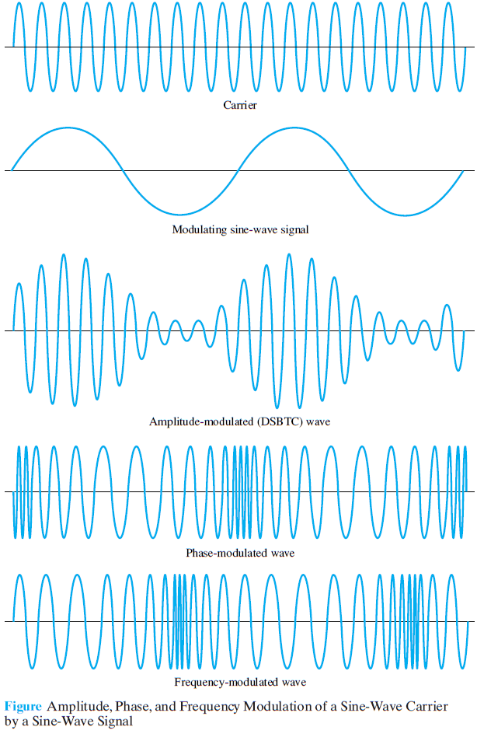
    - Analog modulation Techniques
Analog modulation is used extensively in broadcasting of audio and video programs, and many old telecommunication systems are also based on analog modulation. All newly developed systems use digital modulation. For broadcasting, analog modulation continues to play a vital role.

- Amplitude Modulation
Amplitude modulation is a technique of frequency integration where the amplitude of carrier signal changes according to the amplitude of modulating signal. The frequency of the carrier is not changed.

If f_{c} is the frequency of the carrier, the carrier can be represented mathematically as A sin(2πf_{c}t). If f_{m} is the frequency of the modulating signal, the modulating signal is represented by B cos(2πf_{m}t). The amplitude-modulated wave is represented by (A + B cos2πf_{m}t) sin(2πf_{c}t).

The bandwidth required for AM is twice the highest modulating frequency. In AM radio broadcasting, the modulating signal has bandwidth of 15 kHz, and hence the bandwidth of an amplitude-modulated signal is 30 kHz.

- Frequency Modulation
In frequency modulation (FM), the frequency of the carrier is varied according to the amplitude of the modulating signal. The frequency deviation is proportional to the amplitude of the modulating signal. The amplitude of the carrier is kept constant.

The bandwidth of the frequency-modulated signal is twice the sum of the modulating signal frequency and the frequency deviation. For example, in FM radio broadcasting, the peak frequency deviation is 75 kHz, and the peak modulating signal frequency is 15 kHz. Hence the bandwidth of the modulated signal is 180 kHz.

- Phase Modulation
In phase modulation, the phase deviation of the carrier is proportional to the instantaneous amplitude of the modulating signal. No practical systems use phase modulation.

    - Digital modulation Techniques
The digital modulation is the process of digital-to-analog conversion in which the characteristics of an analog signal based on the information in digital data. Figure shows the relationship between the digital information, the digital-to-analog modulating process, and the resultant analog signal.
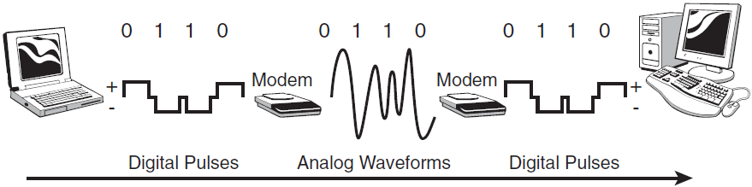

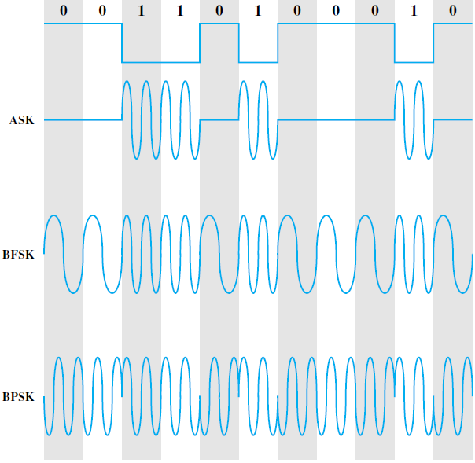
When we have transmit the digital bit stream, we convert the bit stream into the analog signal, Ac cos (ωt + θ). This signal has amplitude Ac, frequency f = ω/2π and phase θ. We can change any of these three characteristics to formulate the modulation scheme. The basic forms of the three modulation methods used for transmitting digital signals are: amplitude shift keying (ASK), frequency shift keying (FSK) and phase shift keying (PSK), which can be shown in figure.

When ω and θ remain unchanged, we have ASK. In this case, the transmitted carrier wave takes two amplitude values during the duration of the pulse. When Ac and θ remain unchanged, we have binary (or M-ary) FSK. In this case the carrier frequency is shifted up or down by a fixed value corresponding to a binary 1 or 0. When Ac and ω remain unchanged, we have binary (or M-ary) PSK. In binary PSK, the information is contained in the phase. During the transmission of a binary 1 the carrier phase is zero, and the carrier phase is changed to a value of π during the transmission of a binary 0.

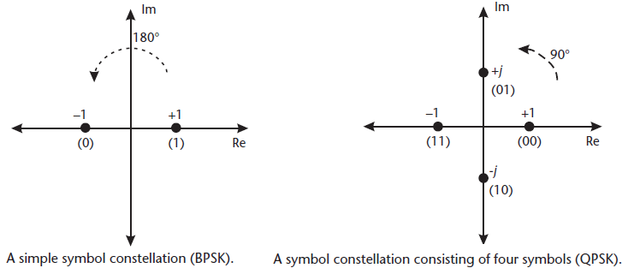
There is various classification of each modulation scheme. The various form of PSK are: binary-PSK or BPSK (one bit per symbol & separation is 360/2 =180 degree), quadrature-PSK or QPSK (two bit per symbol & separation is 360/4 = 90 degree), 8PSK (four bit per symbol & separation is 360/8 =45 degree) & so on. The diagrammatic representation of BPSK and QPSK is shown in figure.

  - Multiplexing
Under the simplest conditions, a medium can carry only one signal at any moment in time. For multiple signals to share one medium, the medium must somehow be divided, giving each signal a portion of the total bandwidth. Multiplexing is the set of techniques that allows the simultaneous transmission of multiple signals across a single data link but it is transparent to end user. Thus, multiplexing is a technique of simultaneous data transmission where multiple data input from several active workstation or device are bind into a single high bandwidth transmission media that can able to carry the whole data traffic. To carry the large number of voice & data transmission simultaneously on the large distance, we use the high capacity fibers, co-axial cable or micro-waves after the multiplexing & the data is again de-multiplexed on the destination.
As we know that the multiple digital bit stream of data are converted into respective analog signal using the digital modulation (i.e. ASK, FSK or PSK) and then these analog signals are combined to transmit through single transmission media using the multiplexing technique.
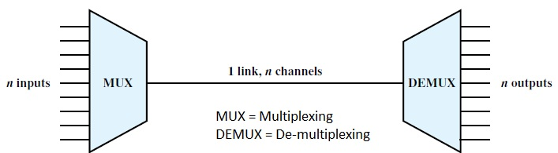
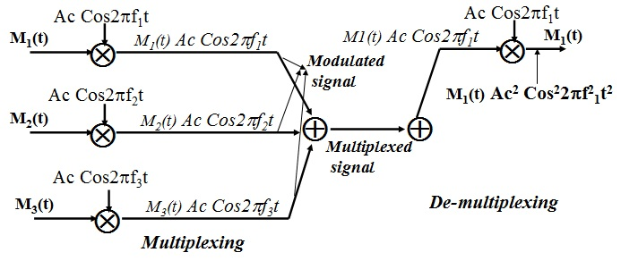

Note: The process of conversation of large number of inputs (m) in to single output is called the multiplexing whereas the process of conversation of large number of input signals (m) into smaller number of output (n) that of the input is called the concentration, for m > n.
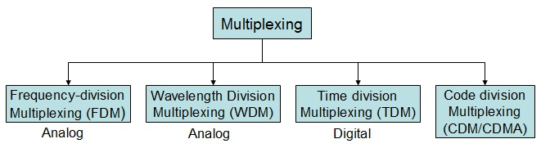
The multiplexing techniques are:
- Frequency division multiplexing (FDM)
- Time division multiplexing (TDM)
- Wavelength division multiplexing (WDM)
- Code division multiplexing (CDM)

- Frequency-division multiplexing (FDM)
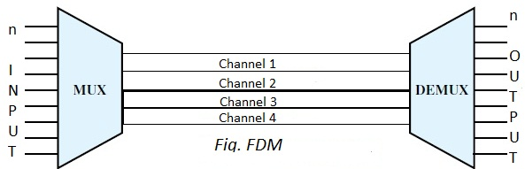
In FDM, the whole transmission bandwidth is divided into several number of frequency bands with some guard bands to separate each bands. Along with these frequency bands the data of active device is transmitted individually.

The one advantage of FDM is that, they are robust i.e. failure one channel does not affect the other sub-channel. The main limitations of FDM are: -
    - The production cost is high because the analog components.
    - Total capacity of channel will reduce by sub-division of channel i.e. we use the guard band to separate the one channel from other.

Frequency division multiplexing is used in broadcast radio and television, cable television, and the AMPS cellular phone systems. This technique is the oldest multiplexing technique that involves analog signaling, it is more susceptible to noise.

- Wavelength-division multiplexing (WDM)
WDM is an analog multiplexing technique to combine optical signals. Wavelength-division multiplexing (WDM) is designed to use the high-data-rate capability of fiber-optic cable. The optical fiber data rate is higher than the data rate of metallic transmission cable. Using a fiber-optic cable for one single line wastes the available bandwidth. Multiplexing allows us to combine several lines into one. The WDM can combine large number of data so some time called as dense WDM (DWDM).

WDM is conceptually the same as FDM, except that the multiplexing and de-multiplexing involve optical signals transmitted through fiber-optic channels. The idea is the same: We are combining different signals of different frequencies. The difference is that the frequencies are very high. The prisms are of opposite side in multiplexing and de-multiplexing.
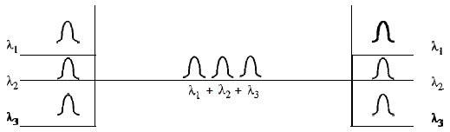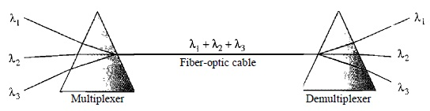

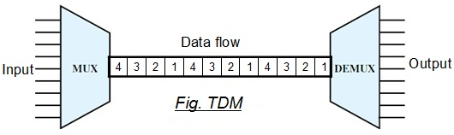
- Time-division multiplexing (TDM)
Time-division multiplexing (TDM) is a digital process that allows combining several low-rate channels into one high-rate one. Instead of sharing a portion of the bandwidth as in FDM, time is shared. Each connection occupies a portion of time in the link. In the TDM, waiting time and some random time (i.e. defined separately for each user to reduce the collision) is defined to dope or insert our message in the timely divided network channel. In the case of GSM same channel is shared by 8-person at a time. TDM is divided as:

    - Synchronous time division multiplexing: In synchronous TDM, the data blocks from several active or passive workstations are collected and transmitted in round robin manner. If we have n connections, a frame is divided into n time slots and one slot is allocated for each unit, one for each input line. If the duration of the input unit is T, the duration of each slot is T/n and the duration of each frame is T.
- Here, the time is assigned to all connected devices without care of data presence or absence.
- T-1 and ISDN telephone lines are common examples of synchronous time division multiplexing.
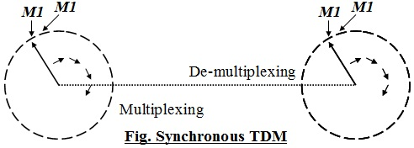
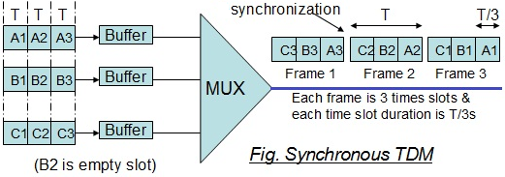

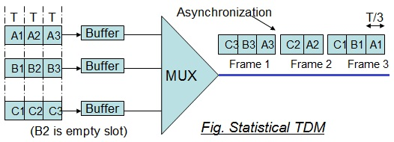
    - Statistical time division multiplexing: In statistical time-division multiplexing, time slots are dynamically allocated for workstations (or why work when you don’t have to) to improve bandwidth efficiency. If a workstation is not active, no space is wasted on the multiplexed stream. Thus, here number of slots in each frame is less than the number of input lines. This technique is good for low bandwidth lines and much more efficient use of bandwidth.

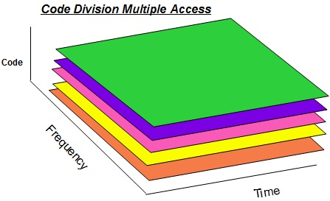
- Code division multiplexing (CDM)
The CDM was an old technique used by US Army for security purpose but now a new method that allows multiple devices to transmit on the same frequencies at the same time using different codes for each user. The codes are orthogonal codes (i.e. cross co-relation zero from other). We generally use 64-bit Walsh code & repeat each data bit up to the Walsh code or spreading sequence and does the Ex-OR operation to generate the transmit data stream. This process is the spreading technique and is done to achieve the diversity gain i.e. explore the good result of information bit at receiver either selecting one best result or by cumulative operation on multiple data. Note that if we use any spreading sequence such as Walsh code, PN-long code or PN-short code etc. without repetition of information data bits is called the scrambling. At the receiver, the appropriate orthogonal code is used again to recover the particular signal intended for a particular user.
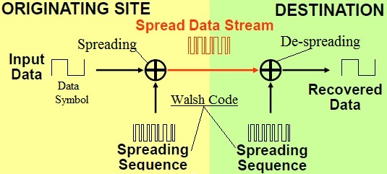
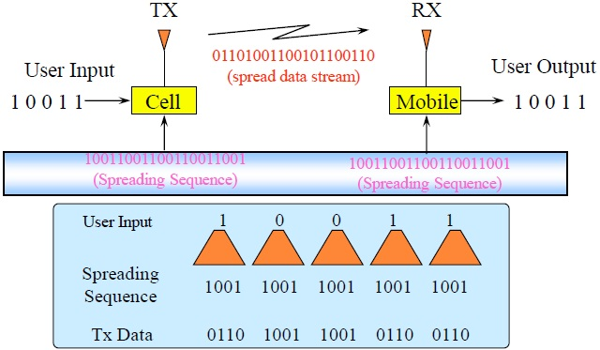
Systems with Code Division Multiple Access (CDMA) are broadband systems, in which each subscriber uses the whole system bandwidth (similar to TDMA) for the complete duration of the connection (similar to FDMA).

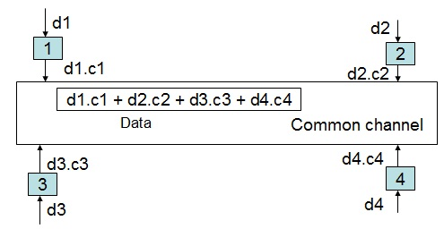
Let us assume, we have 4 stations 1, 2, 3, & 4 connected to the same channel. The data from station 1 is d1; from station 2 is d2 and so on. The code assigned to the first station is C1; to the second is C2 & so on, then:

NOTE:
Walsh Code
The Walsh codes are orthogonal codes. Two codes are orthogonal if the result of exclusive-OR-ing them results in an equal number of 1's and 0's. Cross-Correlation between two orthogonal codes is Zero. Hadamard Matrixes used to generate Orthogonal Codes. The codes are unique in each row. The 64 by 64 Walsh function matrix (also called a Hadamard matrix) is generated by the following recursive procedure;
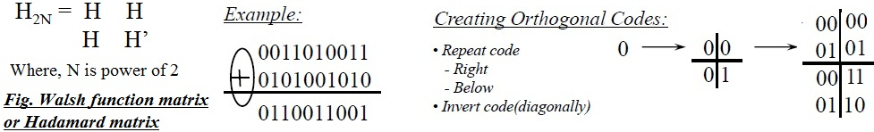

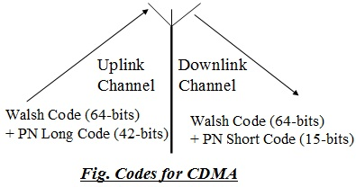
PN Long Code
    - PN stands for Pseudorandom Number, used through the control channel.
    - PN long code is up-link spreading code.
    - It is a 42-bit code.

PN Short Code
    - PN short code is a BTS sector (defined by α, β & γ) code that used in down-link channel.
    - It is a 15-bit binary code.

Multiplexing Technique | Advantages | Disadvantages
Frequency Division Multiplexing (FDM) | - Simple  - Popular with radio, TV, cable TV.  - Relatively inexpensive  - The entire receiver such cellular telephone, do not need to be at the same location. | - Analog signal only  - Limited by the frequency range
Synchronous Time Division Multiplexing | - Digital signal  - Relatively simple  - Commonly used with T-1 and ISDN. | - Wastes bandwidth
Static Time Division Multiplexing | - More efficient use of bandwidth  - Packets can be various sizes.  - Frame can contain control & error information. | - More complex than the Synchronous Time Division Multiplexing
Dense Wavelength Division Multiplexing | - Very high capabilities over fiber.  - Scalable  - Signals can have varying speed | - High cost  - Complexity
Code Division Multiplexing | - Large capabilities  - Scalable | - Complexity

